

School of Surveying & Built Environment

Total Station Differential Levelling Procedure – Topcon Field

V1.1

# Document History

|  |  |  |  |  |
| --- | --- | --- | --- | --- |
| **Date** | **Version** | **Issue** | **Amendments** | **Author(s)** |
| 18/07/2024 | 0 | 1 | Document Created | CMcA & KZ |
| 14/03/2025 | 1 | 1 | Update for Magnet to Topcon name change | CMcA |
|  |  |  |  |  |
|  |  |  |  |  |

Contents

Document History 2

1. Introduction 4

2. Point naming conventions 5

3. Example run 6

4. Configuring Topcon Field 8

4.1. Establishing a new job 8

4.2. Instrument settings 8

4.3. Setup menu 13

5. Starting the Differential Levelling Survey 16

5.1. Initial Occupation 16

5.2. Observing the Foresight 19

5.3. Moving to a new Occupation 20

5.4. Downloading your job file 21

6. Uploading TS Differential Levelling to Topcon Tools 22

6.1. Initial Import into Topcon Tools 22

6.2. Averaging observations in a Spreadsheet 24

6.3. Example calculations 24

6.4. Entering your level data into Topcon Tools 25

7. Appendix A: Manual Entry of Levelling Data into Magnet/Topcon Tools 26

# Introduction

This document has been prepared to provide a practical explanation and instructions for differential levelling using TOPCON FIELD with a TOPCON Total Station and a fixed height pole.

The overview of this technique is outlined in the “Total Station Differential Levelling Procedure” document available on GitHub, available here: <https://github.com/UniSQ-Surveying/Differential_Levelling>

It is based on the process outlined in the Special Publication 1 v2.2 Guideline for Differential Levelling Section 3.2. The Guideline is available on the [ICSM website here.](https://www.icsm.gov.au/publications/guideline-control-surveys-differential-levelling-v22)

This method out lined in this document was developed by UniSQ student Kristy Zemski as part of her University studies, under the guidance of Queensland Department of Resources Geodetic Surveyor, Garry Cislowski, and UniSQ Professional Fellow (Surveying), Chris McAlister. Contributions were also made by Joe Culliver, Jordan Williams, Damian Forknall and Andrew Cleland.

This document, along with additional resources, can be downloaded from the UniSQ Surveying GitHub.

This document will be updated over time, however if you have feedback or comments, please contact Chris McAlister at [chris.mcalister@unisq.edu.au](mailto:chris.mcalister@unisq.edu.au)

# Point naming conventions

Before commencing the configuration of the Total Station and job settings, it is critical to understand the point naming conventions used throughout this process.

The Total Station will never be set up over a mark (as is the case with traditional differential levelling) so the naming of the Total Station occupation is simply:

* OCCX
  + Where “X” is the number occupation the Total Station is at. E.g. “OCC1” is used for Total Station setup 1, “OCC2” for 2 and so on.

This occupation number is then used as the prefix for the backsight and foresight observation numbering, which are three digits, such as:

* Backsight: 101
  + Where the first “1” indicates the occupation number
  + The next two digits “01” indicate the mark that the Total Station is observing to – in this example our first backsight from occupation 1
* Foresight: 102
  + Again, “1” indicates the occupation number
  + “02” indicates the second mark observed – our first foresight

At the second occupation our numbers will be:

* Occupation: OCC2
* Backsight: 202
  + This indicates we are observing to mark “02”, our previous foresight
* Foresight: 203
  + This indicates we are observing to mark “03”, our new foresight

This pattern continues until the survey is complete, noting that the point numbers will also be used on the reverse run.

Drawing a field note sketch of your level run as you go will be helpful to maintain point numbering conventions.

# Example run

1. Forward Run: First set up

|  |  |  |  |  |
| --- | --- | --- | --- | --- |
|  |  |  |  |  |
| PSM123 | BS | OCC1 (TS) | FS | CP1 |
| 101 |  |  |  | 102 |

* 1. TS Occupation is called **OCC1**
  2. Backsight is set to point name: **PSM123**
  3. Level observations to backsight point are called **101**
  4. Level observations to foresight point are called **102**
  5. Foresight is set to point name: **CP1**
  6. Move TS to next occupation **OCC2**

1. Forward Run: Second set up

|  |  |  |  |  |
| --- | --- | --- | --- | --- |
|  |  |  |  |  |
| CP1 | BS | OCC2 (TS) | FS | CP2 |
| 202 |  |  |  | 203 |

* 1. TS Occupation is called **OCC2**
  2. Backsight is set to point name: **CP1**
  3. Level observations to backsight point are called **202**
  4. Level observations to foresight point are called **203**
  5. Foresight is set to point name: **CP2**
  6. Move TS to next occupation **OCC3**

1. Return Run: First set up

|  |  |  |  |  |
| --- | --- | --- | --- | --- |
|  |  |  |  |  |
| CP2 | BS | OCC3 (TS) | FS | CP1 |
| 303 |  |  |  | 302 |

* 1. TS Occupation is called **OCC3**
  2. Backsight is set to point name: **CP2**
  3. Level observations to backsight point are called **303**
  4. Level observations to foresight point are called **302**
  5. Foresight is set to point name: **CP1**
  6. Move TS to next occupation **OCC4**

1. Return Run: Second set up

|  |  |  |  |  |
| --- | --- | --- | --- | --- |
|  |  |  |  |  |
| CP1 | BS | OCC4 (TS) | FS | PSM123 |
| 402 |  |  |  | 401 |

* 1. TS Occupation is called **OCC4**
  2. Backsight is set to point name: **CP1**
  3. Level observations to backsight point are called **402**
  4. Level observations to foresight point are called **401**
  5. Foresight is set to point name: **PSM123**

# Configuring Topcon Field

## Establishing a new job

1. Open Topcon Field
2. Connect your controller to your Total Station via Bluetooth
3. Create a new job for your Differential Levelling with a Total Station job. The software will treat your level run as a traverse. If you accidentally combine your level run with actual traverse data it is very difficult to untangle and will confuse the software immensely!

## Instrument settings

1. From the main menu, selection **Configure**, the **Survey**
2. Select **Edit** in the Optical Configuration section, as shown below.

1. Change the **Name** field to TS DIFF LEVEL with the **Type** as Robotic. Click Next.

1. On the **Instrument** screen, set the Manufacturer and Model as appropriate. Then enter the following values for Height of Reflector (HR) and Height of Instrument (HI), then click **Next** when complete.
   1. **Foresight HR** = 0.000m
   2. **Backsight HR** = 0.000m
   3. **HI**: 0.000m

1. On the **Connection Mode** screen select **Bluetooth TS** and click Next.

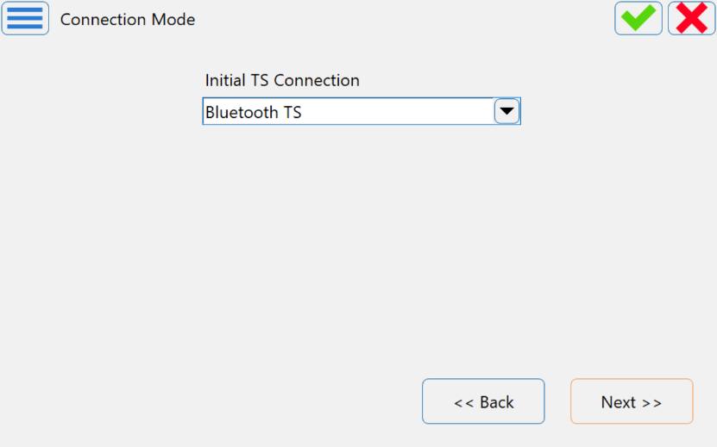

1. On the **Search/Track** screen accept the default settings and click Next

1. On the **Survey Settings** screen 1, set the following values, then click **Next**.
2. **Meas method**: Direct/Reverse (this is Topcon speak for FL/FR)
3. **Search After Turn:** Search and Aim
4. Set tolerance as appropriate for your job

1. On the **Survey Settings** screen 2, set the following values, then click **Next**.
2. Measurement type: **HA/HD/VD** (this assists with display options only)
3. Set BS and FS Target to **ATP1 360** (or other prism being used)

1. On the **Survey Settings** screen 3, set the following values, then click **Next**.
2. Select **Precise** EDM mode, and
3. Set **EDM Mode** to **Fine**

1. On the **Auto Topo** screen click **Next**.
2. On the **Monitor Options** screen, set the following values, then click **Next**.
3. **Measurement method**: Direct/Reverse
4. **Sets**: 1
5. Ensure “Store as checkpoint” is not ticked

1. On the **Topo Output Config** screen, click **Next**.
2. On the **Stake Settings** screen 1, click **Next**.
3. On the **Stake Settings** screen 2, click **Next**.
4. On the **Grade Stake Marking**, click **Next**.
5. On the **Stake Settings** screen 3, click **Next**.
6. On the **Staked Point Icon** screen, click **Next**.
7. On the **Point Naming** screen, set the following values, then click **Next**.
   1. **Increment Point Number**: 0
   2. **Prefix Suffix**: None

1. On the **Miscellaneous** screen, select the following settings as ticked as a minimum:
   1. Right/Left Rod to TS
   2. Beep on Storing Points
   3. Automatically display BS Setup
   4. Remember Occ/BS if set
   5. Prompt for Travers Advance

1. Click the **Green Tick** in the top right corner.
2. Click the **Green Tick** in the top right corner of the **Job Configuration** screen.
3. Note that your Total Station might disconnect and then prompt you to reconnect to the controller at this point. This is normal, just connect as previously.

## Setup menu

1. Select the **Setup** icon on the main screen (tripod icon), then **Backsight**.

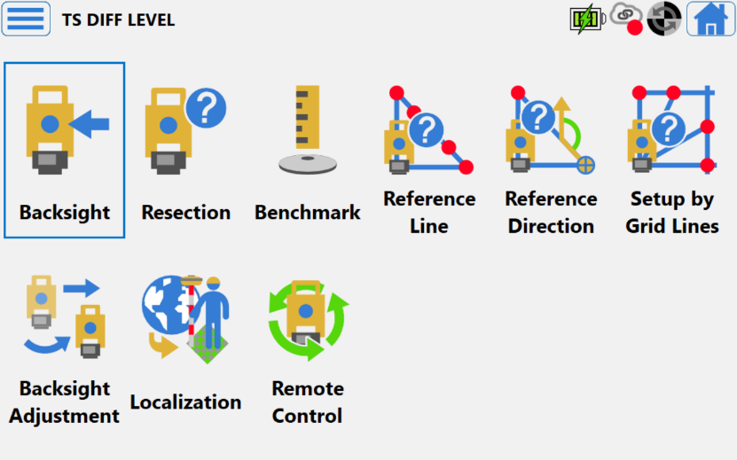

1. On the **Backsight** screen:
   1. Enter the **Occupation Point** information as below
   2. Enter the **Backsight Point** as the actual name/number for the mark you are using in your survey.
   3. Click **Next**

1. You will receive a **Warning** screen telling you the Occupation point has not been found. Click **Next**.
2. On the **Add Point** screen, enter arbitrary values for East, North and Elevation. You can take a photo of your set up using the Photo tab if you like. Then click the **Green Tick** button.

1. You may receive a **Warning** screen telling you the Backsight point has not been found. If so, click **Next**.
   1. On the **Add Point** screen, enter arbitrary values for East, North and Elevation that are different to your Occupation Point coordinates!
   2. Add photo of your set up and mark using the **Photo** tab
   3. Then click the **Green Tick** button.
2. This will take you to a Backsight Measurement screen.
   1. Check that the heading at the top of the screen shows **Backsight -Direct/reverse: Normal**.
      1. If it doesn’t, select the **Cogs symbol** button near the top right and change the settings as per the instructions in Section 4.2, Point 7 onwards.
   2. Enter an approximate Magnetic Bearing into **Set Circle to** from your Total Station to the Backsight.
   3. Centre the Total Station crosshairs on the prism at the Backsight (remember to do your parallax error checks!)
   4. Push the **Set** Button

* 1. It will then prompt you to measure your Backsight in Reverse (FR)
  2. Centre the Total Station crosshairs on the prism at the Backsight (remember to do your parallax error checks if you have changed user.)
  3. Select the Measure button in the bottom right.

1. The **Backsight-Direct/Reverse** screen 1 will open, giving you the information from your Backsight observations. If they are acceptable, click **Accept**.
2. The **Backsight-Direct/Reverse** screen 2 will open, giving you the information from your Backsight observations. Click the **Home** button (the blue house icon) in the top right corner.
3. You will be returned to the main menu.

# Starting the Differential Levelling Survey

## Initial Occupation

1. Commence the survey by selecting **Survey** then **Topo**

1. This will open the measurement screen. It should say **Sideshot-Direct/Reverse Normal** at the top of the screen.
   1. Topcon uses the term Sideshot for any points that are not Control points (e.g. BS and FS points).
   2. In this measure screen you have the option to measure **Sideshots** or **Traverse** points.
   3. To change between them, select the button in the top left (this will be an M in Magnet branded versions, or a T in Topcon branded versions), then select **Measure** from the drop-down menu, and select the measurement option you wish to use.
   4. You should use **Sideshot** mode for measuring your Levelling observations, and **Traverse** mode for your Backsight and Foresight measurements.
2. In **Sideshot** mode:
   1. Complete the Point numbering according to the convention outlined in Section 2. Enter the point number as a three digit number with the first number being the occupation point number and the final two numbers being the point increment number e.g.: 101 – 1 being the occupation point and 01 being the observation point number.
   2. Ensure your height is set to 0.000m
   3. Centre the Total Station crosshairs on the prism at the Backsight in FL.
   4. Press the Measure button in the bottom right (the Total Station), or the measure and save button (Total Station with the green tick).
3. You will then be prompted to measure the Backsight in **Reverse** (FR).
   1. If you are using ATR, the instrument will automatically turn to FR and aim at the prism. Check the crosshairs are centred on the prism using the telescope prior to undertaking any measurements.
   2. If you are not using ATR, turn into FR and centre on the prism.
   3. Press the Measure button in the bottom right (the Total Station), or the measure and save button (Total Station with the green tick).

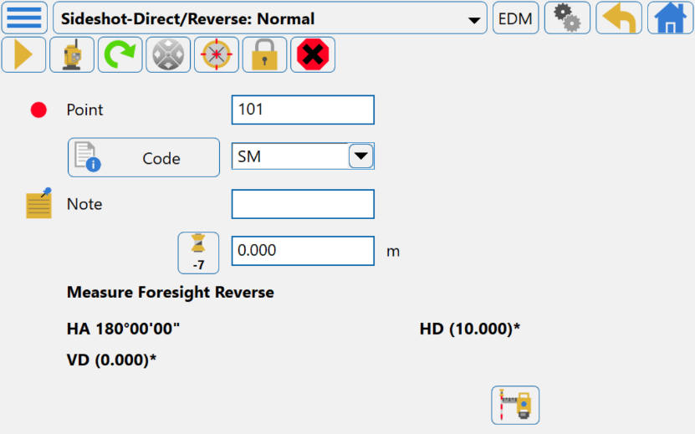

1. The **Sideshot-Direct/Reverse** screen 1 will open, giving you the information from your Backsight observations. If they are acceptable, click **Accept**.
2. The **Sideshot-Direct/Reverse** measurement screen will reopen.
   1. Make sure your instrument is in FL aimed and centred on your Prism.
   2. **Do not change the point number!**
   3. Because the point increment is set to zero, you can just click measure for the second set of Direct/Reverse (FL/FR) readings
3. A **Point Check** screen will appear as you have measured a duplicate point. This is ok!
   1. Select **Store as checkshot?**
   2. **\*\*IMPORTANT\*\*** You **MUST** select the tick box **Used in weighted average**
      1. This feature will include this second set of observations with the first as if you were completing multiple sets.
   3. Select the **Green Tick**

1. You will again be returned to the **Sideshot** measurement screen.
   1. Repeat one more set of observations as per steps 6 & 7 above.
   2. This will ensure you have one Direct/Reverse Sideshot observation and two Direct/Reverse check shots included in the weighted result to the same point.
2. You will be presented with the **Weighted Average** screen once you have completed the second check shot.
   1. Check that there are no unexpected Residuals in any of the observations.
   2. If there is one or more erroneous observations, you will need to take additional check shots (in Sideshot mode) to ensure you have three good observations.
      1. Ensure any erroneous observations are set to not be included in the weighted average.
   3. If the three observations are ok, click the Green Tick to be returned to the measurement screen.

1. Move the Prism to the Foresight mark.
2. In the **Sideshot** measurement screen:
   1. Turn the instrument in FL to the Foresight prism, ensuring the crosshairs are centred on the prism.
   2. Ensure you have updated the point number appropriately.
   3. Repeat steps 3 through 8 from above, to take the Foresight readings. Ensure you have three good readings to the foresight mark for your levelling observations.

## Observing the Foresight

1. Once you have completed your Level observations to the Foresight station, change into **Traverse** measurement mode
   1. To change to Traverse mode, select the button in the top left (this will be an M in Magnet branded versions, or a T in Topcon branded versions), then select **Measure** from the drop-down menu, and select Traverse.

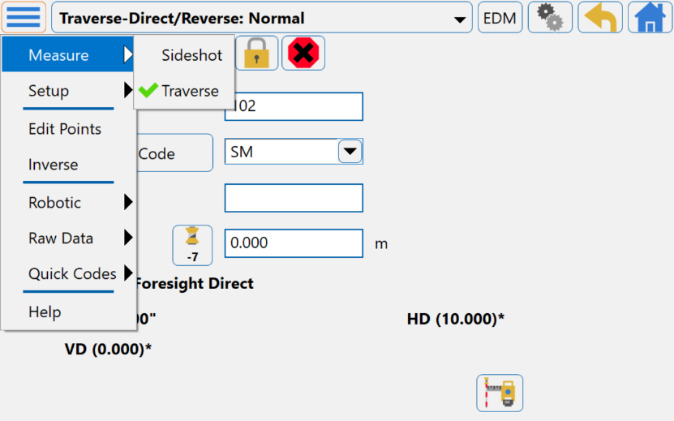

* 1. Enter your Foresight mark number.

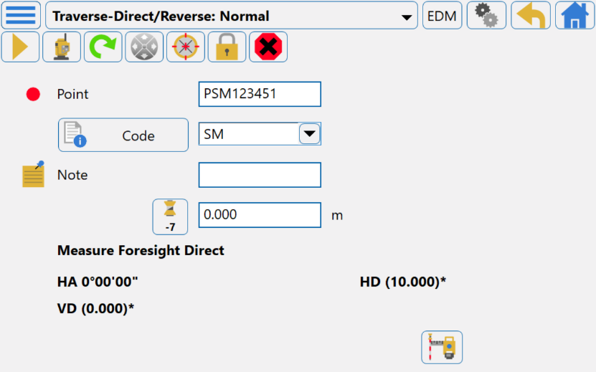

1. You will receive a **Warning** screen telling you the point has not been found. Click **Next**.
   1. On the **Add Point** screen, enter arbitrary values for East, North and Elevation. You can take a photo of your set up using the Photo tab if you like. Then click the **Green Tick** button.
2. You will be returned to the measurement screen.
   1. Ensure it is still in **Traverse**  mode at the top of the screen.
   2. You will now be prompted to observe your Foresight Direct (FL).
   3. Ensure the Total Station crosshairs are still on the prism at the Foresight.
   4. Press the Measure button in the bottom right (the Total Station), or the measure and save button (Total Station with the green tick).
3. You will then be prompted to measure the Foresight in **Reverse** (FR).
   1. If you are using ATR, the instrument will automatically turn to FR and aim at the prism. Check the crosshairs are centred on the prism using the telescope prior to undertaking any measurements.
   2. If you are not using ATR, turn into FR and centre on the prism.
   3. Press the Measure button in the bottom right (the Total Station), or the measure and save button (Total Station with the green tick).
   4. The **Foresight – Direct/Reverse** screen will open, giving you the information from your Foresight observations. If they are acceptable, click **Accept**.
4. The program will now prompt you to move the instrument. Select **Yes.**

## Moving to a new Occupation

1. Power down the instrument and move it safely to your next occupation point, approximately halfway between your next Backsight and Foresight marks.
   1. Do NOT move the prism at this point.
2. Power on the instrument and reconnect it to the controller.
   1. In **Topo**, you will be prompted to enter your occupation and Backsight information again.
   2. Enter the information for your new occupation as per previous steps.
   3. Enter the Backsight information as per previous steps.
   4. Ensure you are in **Traverse** measurement mode, observe the Backsight Direct/Reverse measurements.
3. Swap into **Sideshot** mode and repeat the above processes to capture your level data.
4. Repeat the above processes for the remainder of the survey until it is complete.

## Downloading your job file

1. Shut down Topcon Field on the controller.
2. Insert a USB stick into the controller.
3. Navigate to the Topcon Field **Jobs** folder in Windows Explorer
4. Copy and paste the entire Job file onto the USB
   1. Note if Topcon Field is still open, there will be a Lock file that will prevent you from importing the job file into Topcon Tools later.

# Uploading TS Differential Levelling to Topcon Tools

**Notes:** As most software doesn’t currently have a field option for collecting differential heights with a TS, most software will also lack an easy import option. This document outlines how to get ‘clean’ your data so it can be imported as differential levels into Topcon Tools. For other software, please see the GitHub repository.

Some of the screenshots below may vary slightly depending on which version of Topcon/Magnet Tools you are using.

## Initial Import into Topcon Tools

1. Import the job file to Topcon Tools as normal.
   1. Note that Topcon will treat your data as a traverse, but as you didn’t set BS/FS or coordinates like normal, it may have a fit that your data is a mess. Don’t panic, this is just a through step to get the data exported into a usable format.
2. Go to Report Configuration
   1. Create a new report called “TS Levelling” as shown below.
   2. Select “TS Observations” from the “Report item templates” list and push the double arrow button to add it “Included report items” side

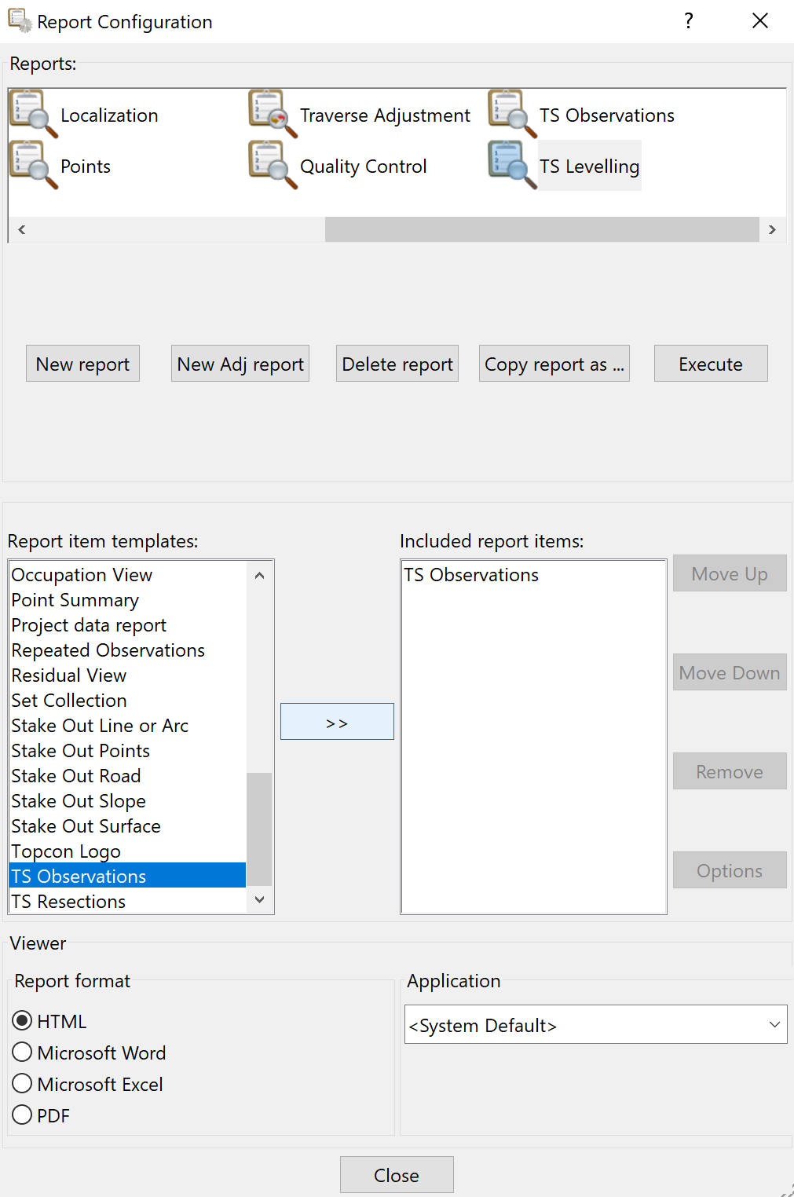

1. Double click on the “TS Observations” to open the menu, as shown in below.
   1. Select the options as shown below.
   2. Note if you did not use averaged/weighted measurements in the field this menu will look different to the figures below.

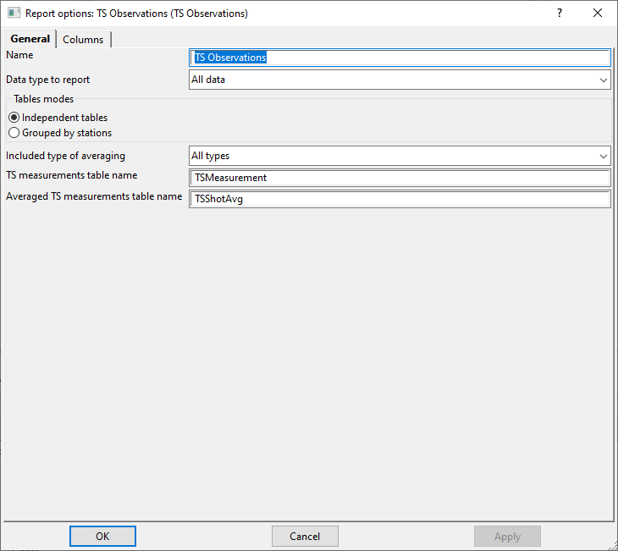

1. Click on the Columns tab, as shown below
   1. Select the options as shown below

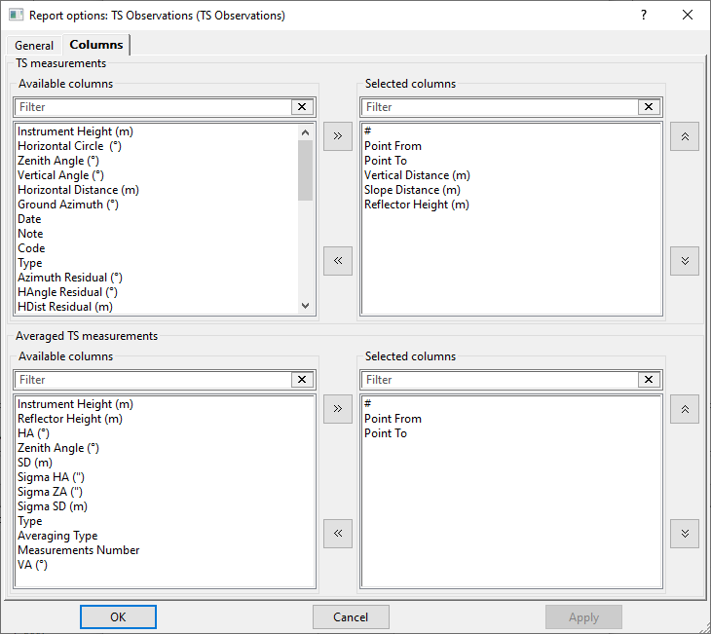

1. Press “Apply” and then “Ok”
2. Once returned to the main report menu, you can now execute the “TS Levelling” report, ensuring you have selected the **Microsoft Excel** export option.
3. This report can now be opened in MS Excel or similar, and you can move to the next process.

## Averaging observations in a Spreadsheet

1. Depending on which field process you have selected, your observations may have been averaged already.
   1. If your observations have not been averaged yet, you will need to do this within the spreadsheet.
2. To determine the differential height between stations using a Total Station, we must use Foresight – Backsight. This is the opposite to levelling with an auto or digi level so make sure you double check you have done it correctly!

## Example calculations

The raw data below in Table 3.4.1 is from a four (4) station level traverse using a single pole, collected at the UniSQ Springfield campus. It is provided as an example of how to reduce the collected data. No adjustment has been made.

|  |  |  |  |  |  |  |  |
| --- | --- | --- | --- | --- | --- | --- | --- |
| **FORWARD RUN** | | |  | **Date** | 15/09/23 | **Project** | UniSQ SF |
| B.S. | Int. | F.S. | Δ Ht (FS-BS) | Rise | Fall | R.L | Remarks |
| -0.469 |  |  |  |  |  | 100.000 | SF3041 |
| 0.044 |  | 0.483 | 0.952 | 0.952 |  | 100.952 | SF3040 |
| 0.371 |  | 0.004 | -0.040 |  | -0.040 | 100.912 | 4000 OIP |
|  |  | 0.120 | -0.251 |  | -0.251 | 100.661 | F108 |
| Σ=-0.054 |  | Σ=0.607 |  | 0.952 | -0.291 |  |  |
| ΣFS-ΣBS= | 0.661 |  | ΣRISE-ΣFALL= | 0.661 | ΔRL= | -0.661 |  |
|  |  |  |  |  |  |  |  |
| **REVERSE RUN** | | |  | **Date** | 15/09/23 | **Project** | UniSQ SF |
| B.S. | Int. | F.S. | Δ Ht (FS-BS) | Rise | Fall | R.L | Remarks |
| 0.113 |  |  |  |  |  | 100.661 | F108 |
| -0.010 |  | 0.363 | 0.250 | 0.250 |  | 100.911 | 4000 OIP |
| 0.455 |  | 0.032 | 0.042 | 0.042 |  | 100.953 | SF3040 |
|  |  | -0.498 | -0.953 |  | -0.953 | 100.000 | SF3041 |
| Σ=0.558 |  | Σ=-0.103 |  | 0.292 | -0.953 |  |  |
| ΣFS-ΣBS= | -0.661 |  | ΣRISE-ΣFALL= | -0.661 | ΔRL= | 0.661 |  |

Table 3.4.1: Example data using a single pole for a level traverse of four (4) marks

## Entering your level data into Topcon Tools

1. Once you have calculated the rise and fall values, completed sum checks and confirmed the data is ok, you can move to entering the data into Magnet Tools using the Manual DL Run function as shown below.

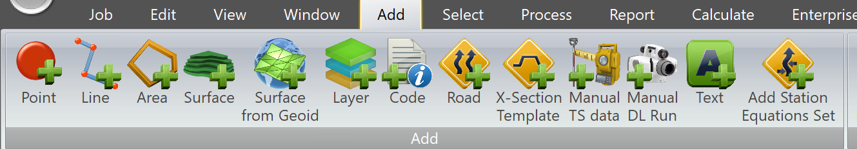

1. Instructions explaining how to use this function are included in Appendix A.

# Appendix A: Manual Entry of Levelling Data into Magnet/Topcon Tools

END OF DOCUMENT